Tarea 1: Juan Carlos Cantillo Soto

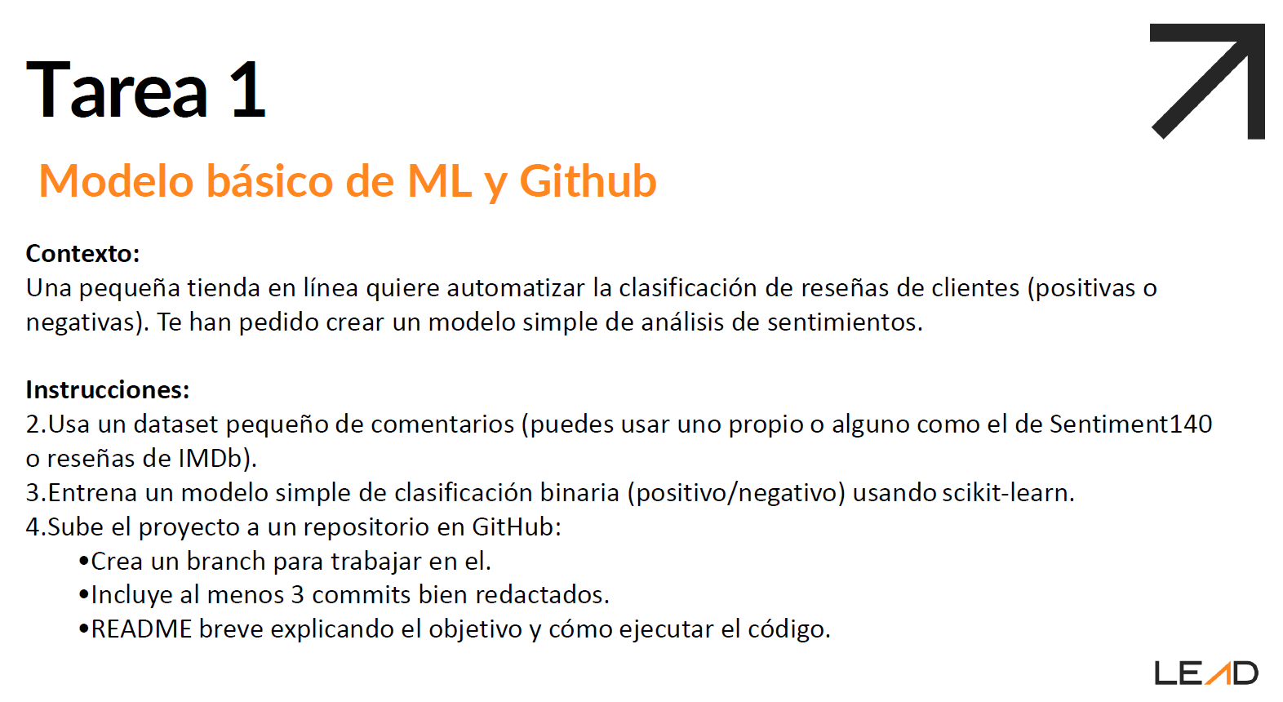

**Solución:**

import pandas as pd

from sklearn.model_selection import train_test_split

from sklearn.feature_extraction.text import CountVectorizer

from sklearn.naive_bayes import MultinomialNB

from sklearn.metrics import classification_report

# Cargar el dataset (solo una muestra por simplicidad)

df = pd.read_csv('training.1600000.processed.noemoticon.csv', encoding='latin-1', header=None)

df = df[[0, 5]] # 0 = Sentimiento, 5 = Texto

df.columns = ['sentiment', 'text']

# Filtrar solo 5000 positivos y 5000 negativos

df = df[df['sentiment'].isin([0, 4])]

df = df.groupby('sentiment').head(5000)

# Convertir 0 → 0 (negativo), 4 → 1 (positivo)

df['sentiment'] = df['sentiment'].replace({0: 0, 4: 1})

# Separar datos

X = df['text']

y = df['sentiment']

# Dividir en entrenamiento y prueba

X_train, X_test, y_train, y_test = train_test_split(X, y, test_size=0.2, random_state=42)

# Vectorizar texto

vectorizer = CountVectorizer(stop_words='english')

X_train_vec = vectorizer.fit_transform(X_train)

X_test_vec = vectorizer.transform(X_test)

# Entrenar modelo

model = MultinomialNB()

model.fit(X_train_vec, y_train)

# Evaluar

y_pred = model.predict(X_test_vec)

print(classification_report(y_test, y_pred))